- Question -1:
Elevated as privilege user. Then updated the repo and installed htop using the commands as per the below screenshot.

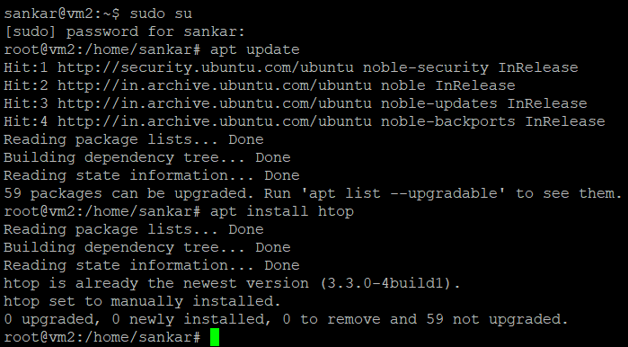
Run the command htop.

This will show the usage details as below.

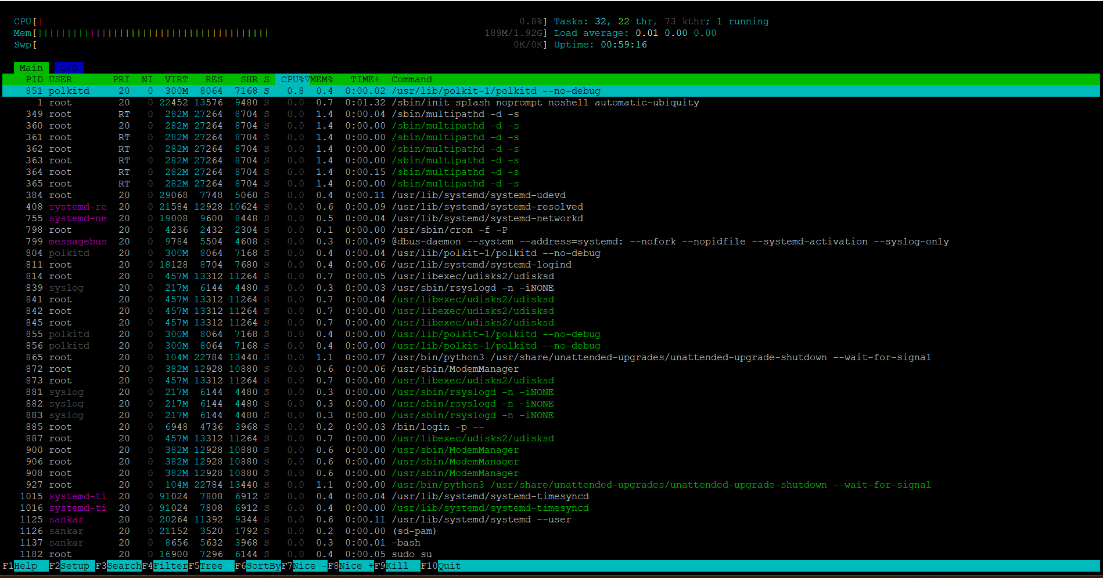

Installed nmon as below.

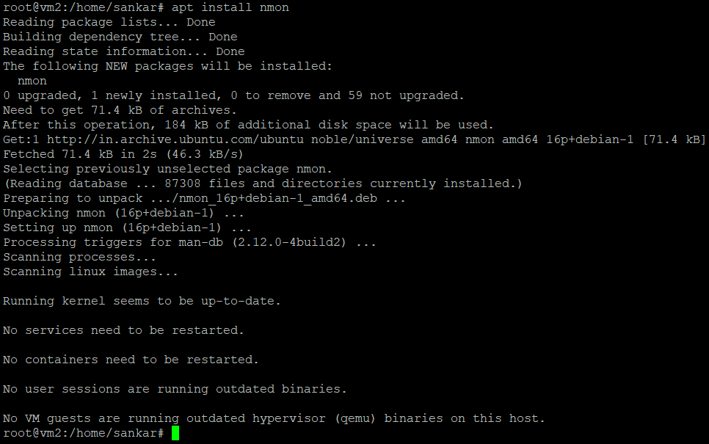

Then run the command nmon, which will show up below image.

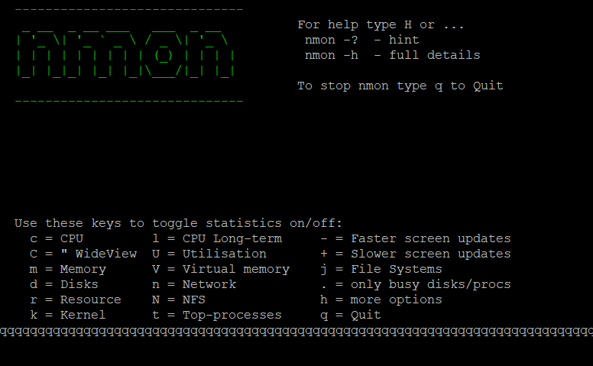

Click on c to get CPU information and m to view memory details which can be seen above.

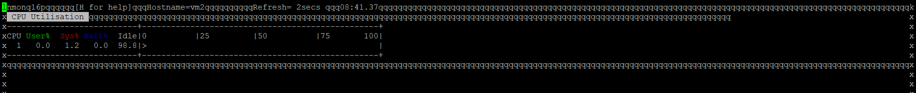

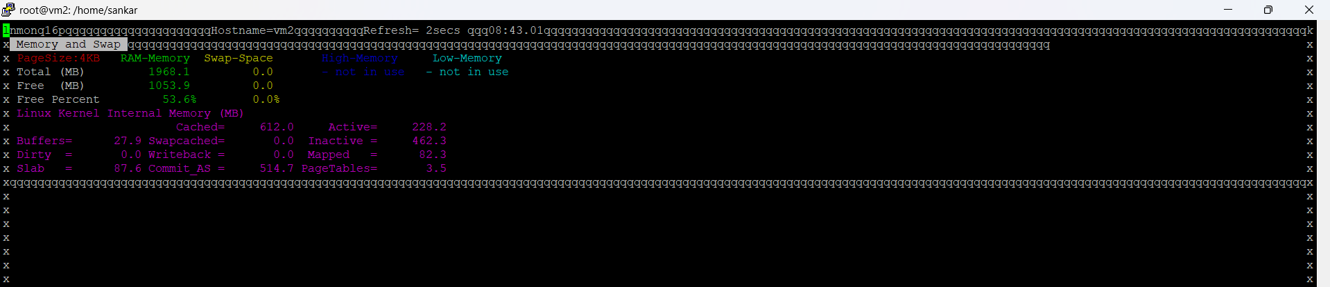

To view disk usage use command df -h.

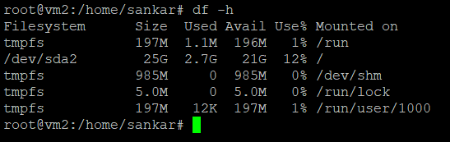

To view a specific directory size details use the command du -sh /directory name/*

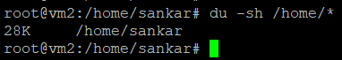

To view most cpu consuming process use the command as per below screenshot
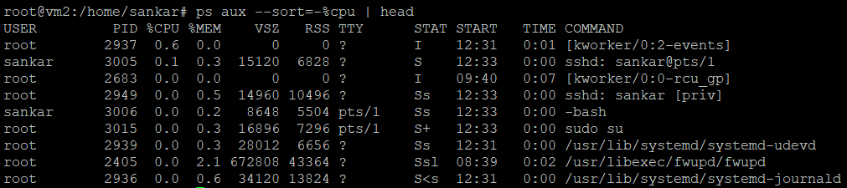

To view most memory consuming process, use the below command.
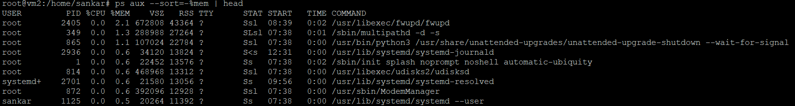

Created a directory in name system_monitoring, in the path /var/log/.

Created script to capture the above-mentioned steps accordingly. In script mentioned the above path to store the captured information.

Provided execution privilege for the script.

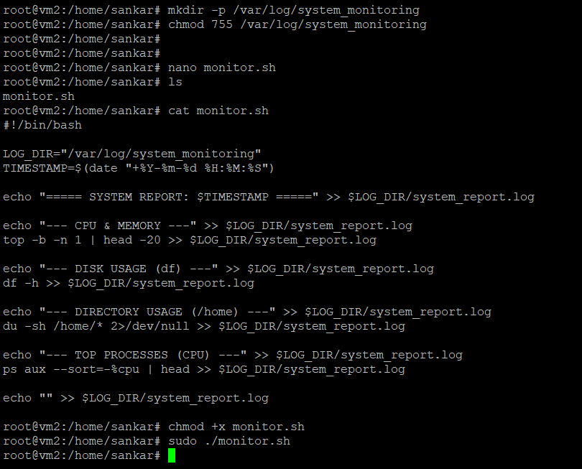

The below screenshot shows the log file being created and the logs is listed.
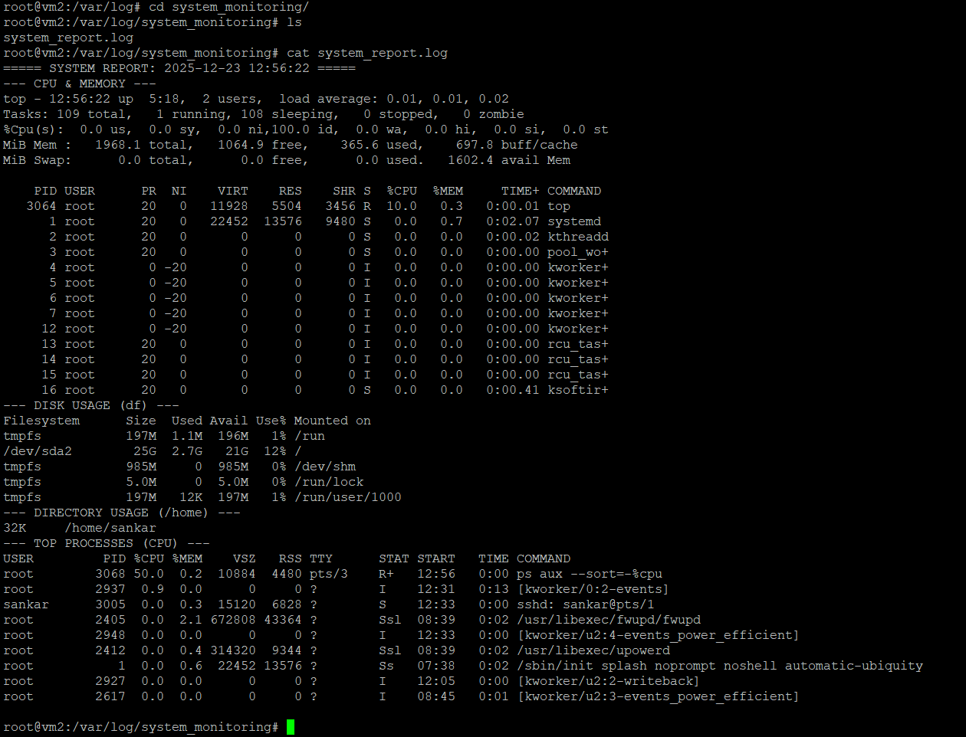

- Task -2:

Created user in the name Sarah and Mike. Also created the password as per below image.
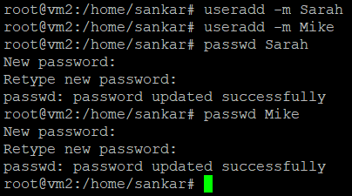
Setted up a dedicated directory for the user Sarah.
Provided the ownership to the user.

Did the same thing for other user Mike.
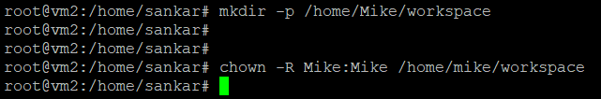

Granted full permission to the owner of the directory.
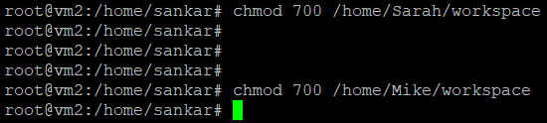
Set up password expiry to 30 days.
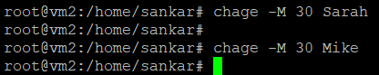
Enforced password complexity, where minlen refers password length, ucredit refers uppercharacter,etc.
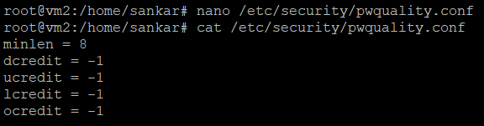

- Task 3:
Created script file named apache_backup.sh and entered below script to backup the backup configuration of apache.
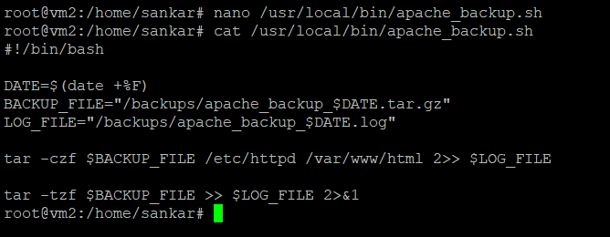
Provided the execution permissions.
Created script file named nginx_backup.sh and entered the below script to backup the backup configuration of nginx.
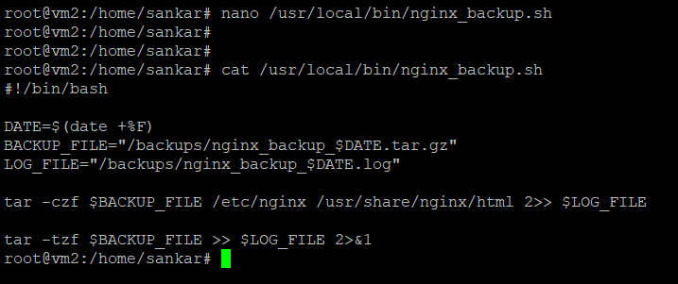
Provided execution permissions.

Created crontab to automate the backup.
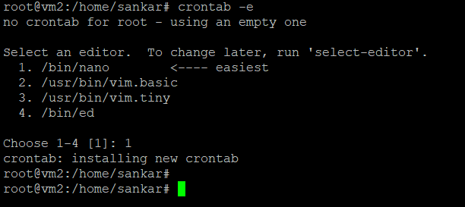
The crontab was scheduled to run at 12 am of Tuesday.
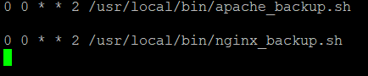
Ran the backup script manually to verify script is working.
